Little Lambs Pre-School Centre
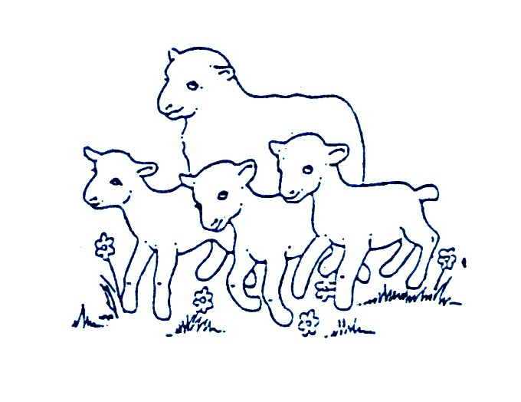
Application Form

Child’s name _______________________ Known as: _____________________

Child’s date of birth __________________ Male/Female ____________________

Address ____________________________________________________________

____________________________________________________________

__________________________ Postcode _________________________

Telephone ____________________________________________________________

Email address _________________________________________________________

Parents full names - Mother _____________________________________________

- Father _____________________________________________

I / We wish to apply for a place at Little Lambs Pre-School Centre as soon as possible /

from ______________________ (Date)

My child qualifies for Time for Twos Funding YES / NO

I have read the Little Lambs Admissions Policy and detail below any information relevant to my child’s application:

______________________________________________________________________

______________________________________________________________________

______________________________________________________________________

If we find that we no longer need the place, we will inform the Pre-School Centre as soon as possible.

Signature of parent: __________________________________________________

Date: __________________________________________________

Please complete and return to:
Little Lambs Pre-School Centre, Bethel Chapel, Hill Street, Wollescote, Stourbridge, West Midlands, DY9 8TL
or email to lambs@bethelchapel.org.uk

